# **Tutorial 1 (star uml)**

1.how to install star uml ?

1.go to staruml.io and download star uml

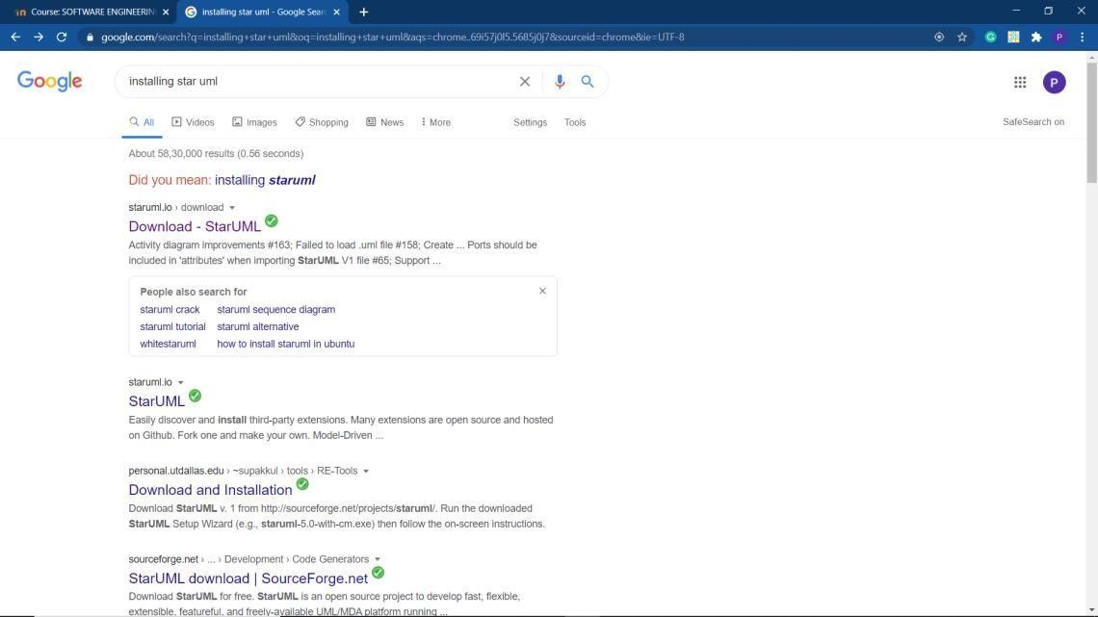

Click the first link

And u will get this page

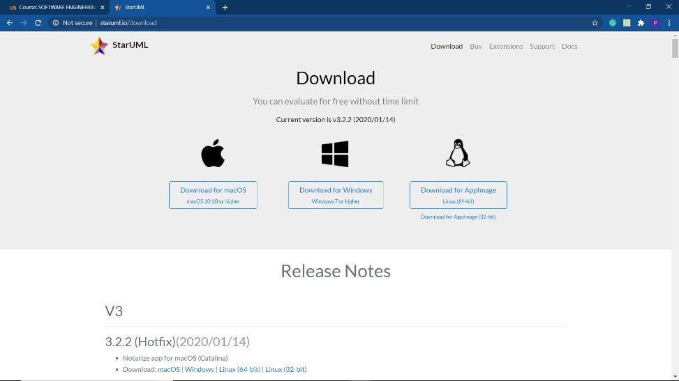

Click download for windows

It will install and go to search button and click star uml

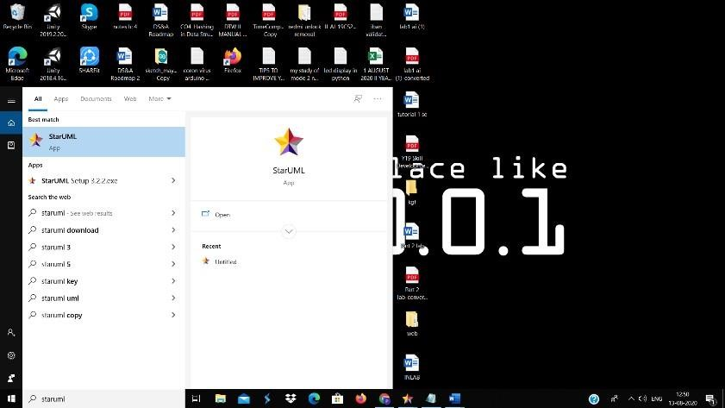

Click on enter

U will get the star uml page and click on evaluate then

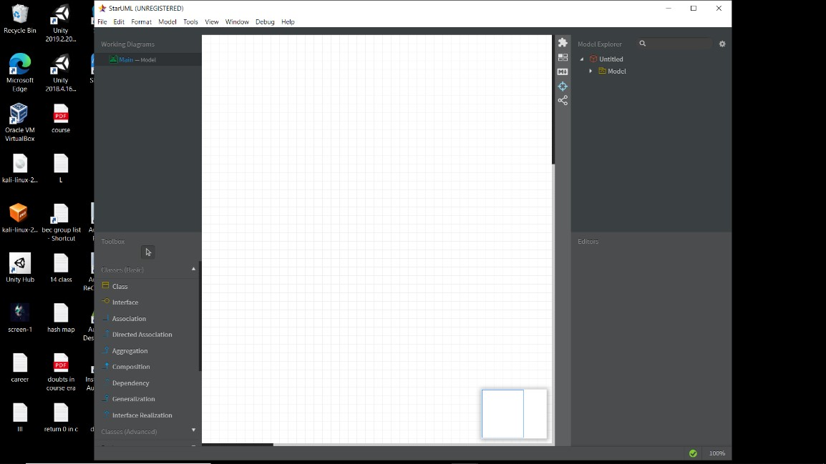

This is the star uml

In star uml in left corner there are working diagram and tool box In right side u have model explorer,editors

in staruml u can draw more diagrams like use case diagram,class diagram…

to open usecase diagram go to modelmenu and click add diagram select usecase diagram

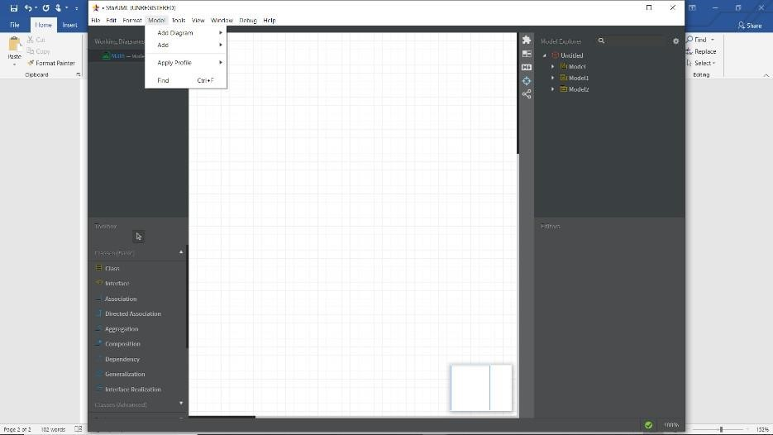

Click on add diagram and select usecase diagram

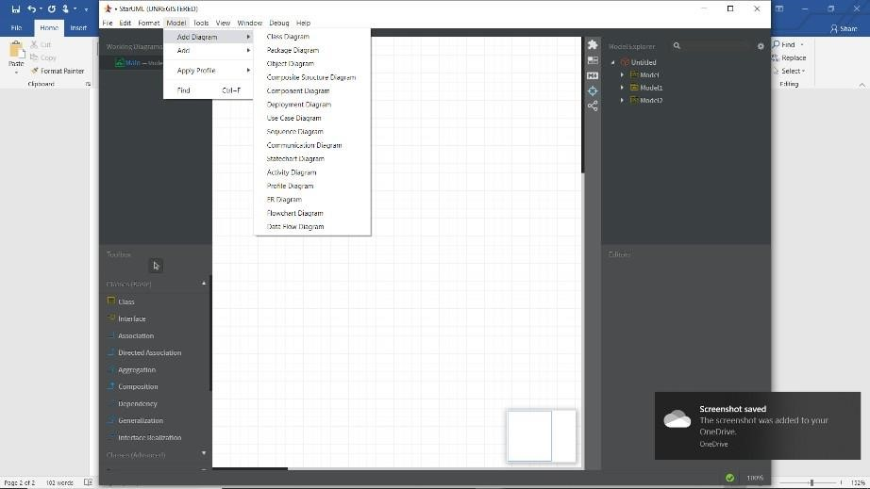

Use case diagram

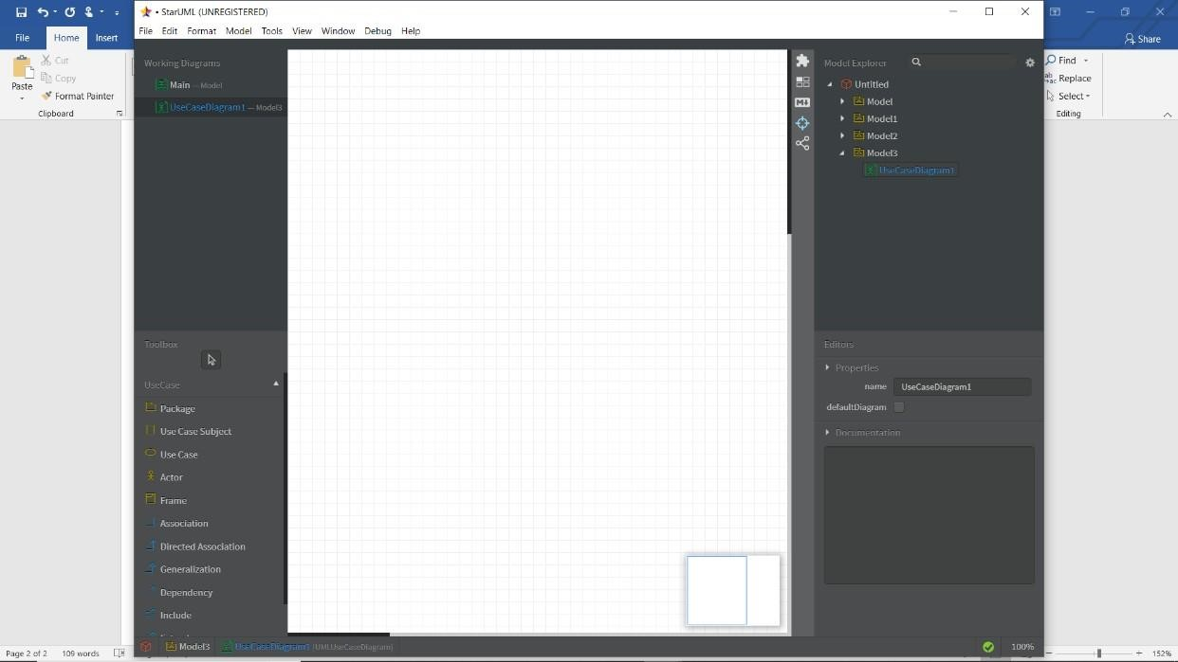

In usecase diagram there is separate tool box see in above diagram There will be package,usecase subject,usecase,actor,frame… And in righthand side there is editor u can change name

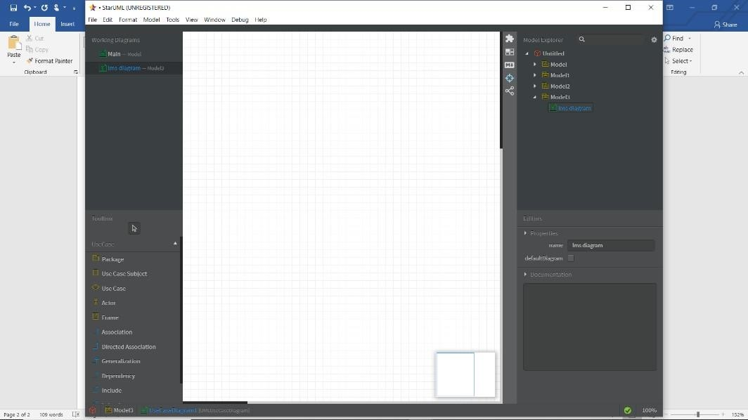

I changed the name (lms diagram) see in above figure

By using actor and usecase we can draw a diagram for example

1 .library management system

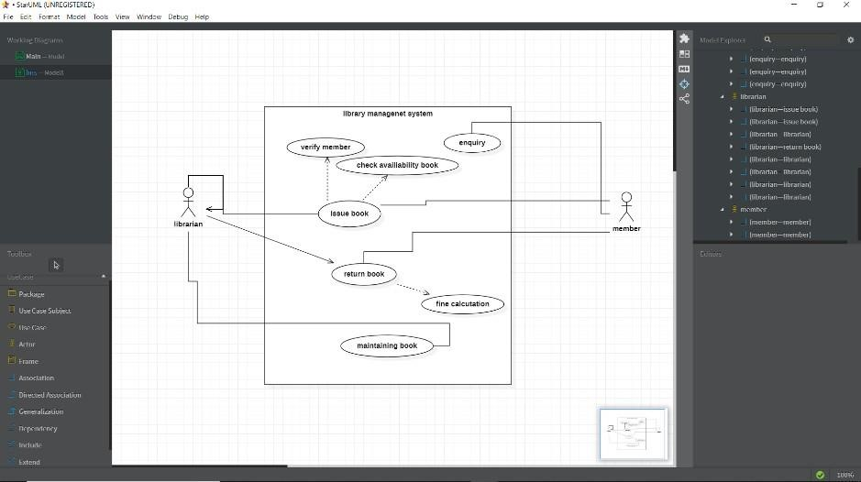

The above diagram is use case diagram

In model explorer u can see what connections we have given

Like we can draw class diagram,activity diagram,sequence diagram,statechart diagram